**Oleh Voloshchuk**

116 Clydesdale Road, Hornchurch, RM11 1AJ | +447404514665 | oleg12345vol@gmail.com

# SUMMARY

I am a computing student at Greenwich University who has just completed a 1st year of Computer Science (Data Science) I have learned in front and back-end programming, I would appreciate the opportunity to learn any new skills. To this end, I am willing to take on accept any feedback that I can use to improve as an employee. I have experience in HTML, a bit of CSS as well as Python, SQL. I have strong communication skills and a solid commitment to teamwork, supported by a track record of volunteering and creative contributions. I am open to new experiences — whether challenging or easy — and have a strong desire to learn new skills that will support my future career growth.

# EXPERIENCE

2018-2022 - Kozovska School #2 charity and social volunteer, for the elderly with disabilities who need help around the home. 2022-2023 - Museum of Docklands created SWAY blog.

2022-2023 – ENO created lyrics with a group of professionals, and performed 17 of March in a Church House, Westminster

# EDUCATION

2022 - 2023 English ESOL Entry 3 level, NCC Ardleigh Green Campus, London RM11 2LL Speaking, presentations, writing letters, articles, reports and Microsoft office. 2013 – 2022 High School Certificate at Kozovska School #2 of 1 – 3 grades (completed higher education)

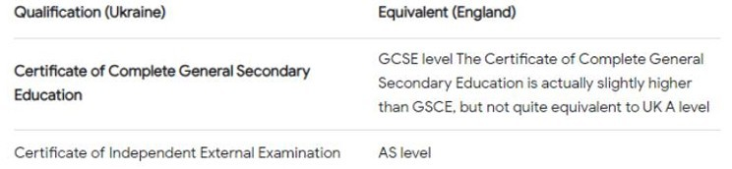

2023-2024 Business level 1 at NCC Ardleigh Green Campus, London RM11 2LL 2024-2025 BSc Computer Science (Data science) 1st year University of Greenwich Currently in 2nd year of study.

**SKILLS AND INTERESTS**

**Languages** • English (fluent) • Russian (fluent) • Ukrainian (native)

# Technical Skills

Programming Languages

* Python (data processing, scripting, web development)
* C / C++ (low-level programming, performance optimization)

Web Development

* HTML (semantic structure, responsive layouts, accessibility)
* CSS (Intermediate level)
* Flask (Python web frameworks)

Database Management

* SQL (Intermediate) — proficient in joins, subqueries, and data manipulation
* Database design and normalization — experienced in structuring efficient relational database

Software Tools & Frameworks

* Git & GitHub (version control, branching, collaboration)
* VS Code, PyCharm
* Linux / Command Line basics
* Virtual environments (venv, conda)

Computer Science Fundamentals

* Data Structures & Algorithms
* Object-Oriented Programming (OOP)
* Operating Systems (processes, memory, scheduling)
* Networking fundamentals (TCP/IP, HTTP, DNS)

# Other Useful Tools

• Figma or Canva (UI/UX design basics)

•Excel / Google Sheets (data analysis)

# Sport Activities

• Swimming: Regular swimmer with strong endurance and focus, promoting fitness and discipline.

• Dance: Passionate about movement and expression; experienced in both modern dance and Ukrainian traditional dance, showcasing cultural appreciation and dedication. • Tennis: Enjoy playing recreationally; helps build concentration, strategy, and persistence.

• Basketball & Volleyball: Active team player; developed strong teamwork, communication, and coordination skills through regular participation.

# Soft Skills

* Problem-solving and analytical thinking
* Attention to detail and debugging ability
* Strong teamwork and communication
* Adaptability and willingness to learn new technologies
* Time management and task prioritization
* Independent project management

# Links

[GitHub](https://github.com/olegi490)

[LinkedIn](http://www.linkedin.com/in/oleh-voloshchuk-0b8698369)